Google App Engine Development Environment Setup

This document describes how to get your environment setup for Google App Engine Development using the Java programming language.

# Assumptions

1. You are familiar with Java programming language and have used Eclipse at the basic level
2. The Java SDK has been installed on your system. Google App Engine supports 1.5 and 1.6, so feel free to have any of those SDKs on your system. If you already have it setup, skip to next step. If not, visit the Oracle Java site and download the 1.6 SDK. Visit <http://www.oracle.com/technetwork/java/javasebusiness/downloads/java-archive-downloads-javase6-419409.html#jdk-6u37-oth-JPR> and download / install the version that is applicable to your OS.
3. An Eclipse version has been setup on your system. The Google Plug-in for Eclipse, which makes development for App Engine easier comes in different flavours that supports different versions of Eclipse, right to the latest version, Eclipse Juno.
4. The recommendation is to have the latest version of Eclipse Juno (Eclipse 4.2) setup on your system. Visit the Eclipse downloads page and set up your Eclipse. Visit <http://www.eclipse.org/downloads/packages/eclipse-ide-java-ee-developers/junosr1> and download the Eclipse Juno version for your OS.

# Installing the Google Plug-in for Eclipse 4.2 (Juno)

1. Start Eclipse and go to **Help 🡪 Install New Software.** You will see a dialog as shown below:

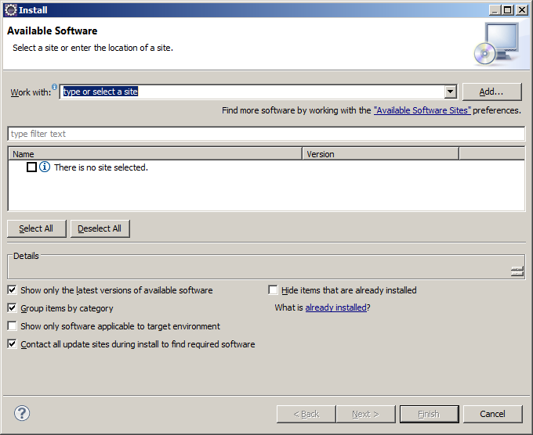

In the **Work with:** input field, enter the update site URL as <http://dl.google.com/eclipse/plugin/4.2> and click on **Add.**

1. This will show a list of software modules that will get installed and it also includes the App Engine SDKs. 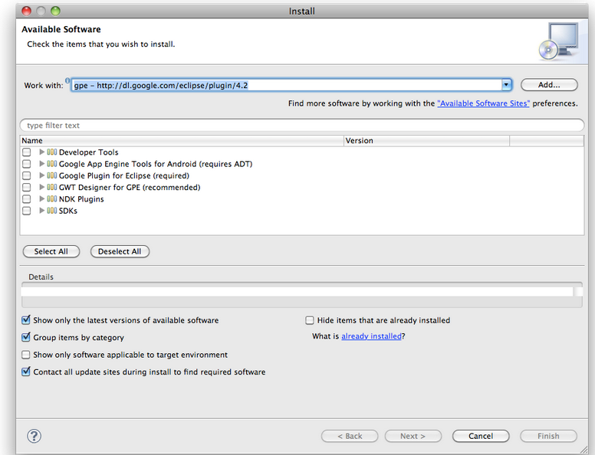
2. You can optionally download the SDK separately also but to keep things simple, select all the options except for the NDK Plugins and click on **Next**.
3. Go ahead and select/accept all defaults. Some of them are shown below:

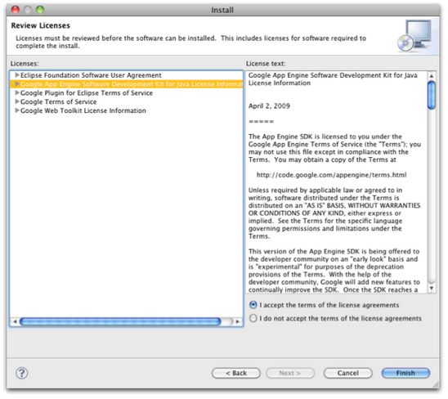

If you see any security warnings while trying to install the software, please go ahead and accept them by clicking on OK.

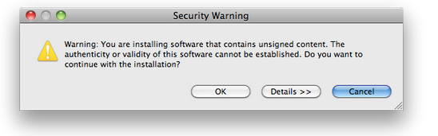

Eclipse will download the modules (could take a while) and then prompt you to restart Eclipse for the changes to take effect. It is recommended that you restart Eclipse by clicking on the **Restart Now** button.

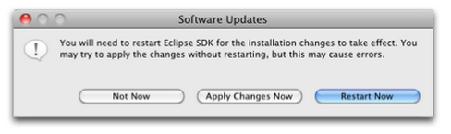

# Verifying your installation

Post your Google Eclipse plugin installation, you should verify and complete your setup by doing the following:

1. Check in the Eclipse main toolbar. You should see an icon for the Google Eclipse Plug-in: 
2. If you click the above, you will see various options as shown below:

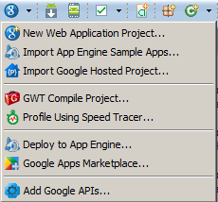

1. From the Eclipse Main menu, click on **Window 🡪 Preferences.** Go to **Google 🡪App Engine.** This should show an App Engine SDK installed and selected for you. Currently you might see only one SDK version selected i.e. the latest one that you downloaded as part of the Google Eclipse plugin. But over time, as you add more SDK versions, you will see a list of them here and you can select the default.

An example screenshot from my machine is shown below. It shows that I have two versions of App Engine SDK on my machine and one of them has been selected as the default SDK to compile again. Note that you can choose a default version any time, even after creating the project.

